LUXURY STAY

(Hotel Management)

(USER GUIDE)

SITE MAP:

HOME (Landing Page)

----------------+--------------+--------------------------------- ---+--------------------------+------
| | | |
[ ROOMS & SUITES ] [ ABOUT US ] [ SERVICES & AMENITIES ] [ CONTACT US ]
|
[ Room Details & Availability ]
|
[ Book Now / Reservation Form ]
|
[ Payment & Confirmation ]

[ USER DASHBOARD ]

+----------------------+-----------------------------+---------------------------------+
| | | |
[ MY RESERVATIONS ] [ PROFILE ] [ GUEST REQUESTS ] [ NOTIFICATIONS ]
- Past Bookings - Edit Profile - Room Service - Booking Alerts
- Active Stays - Account Settings - Maintenance Request - Status Updates
- Cancel Booking - Logout - Feedback & Ratings

[ ADMIN / STAFF DASHBOARD ]

+------------------------------------+---------------------------------+--------------------------------+
| | | |
[ ROOM MANAGEMENT ] [ RESERVATION CONTROL ] [ HOUSEKEEPING ] [ ANALYTICS & REPORTS ]
- Inventory Setup - View All Bookings - Cleaning Tasks - Occupancy Rates
- Pricing & Rates - Check-In / Check-Out - Status Updates - Revenue Trends
- Status Tracking - Assign Rooms - Maintenance Logs - Guest Insights
|
[ STAFF PROFILES ]
- Manager, Receptionist, Housekeeping Roles

SIGN UP / LOGIN FORM:
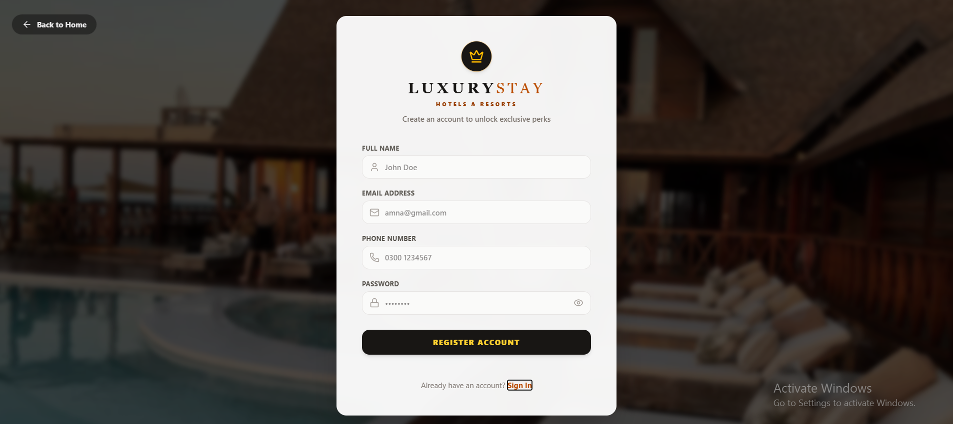

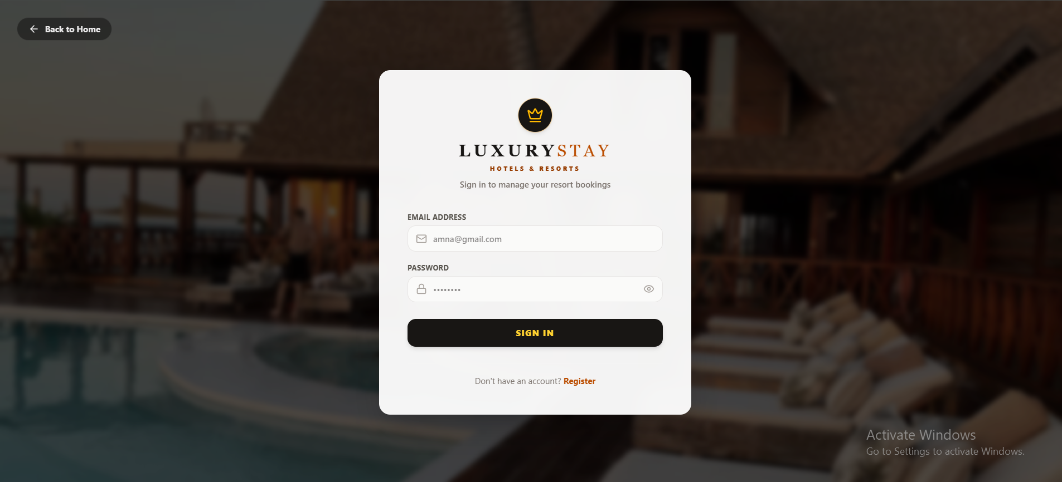

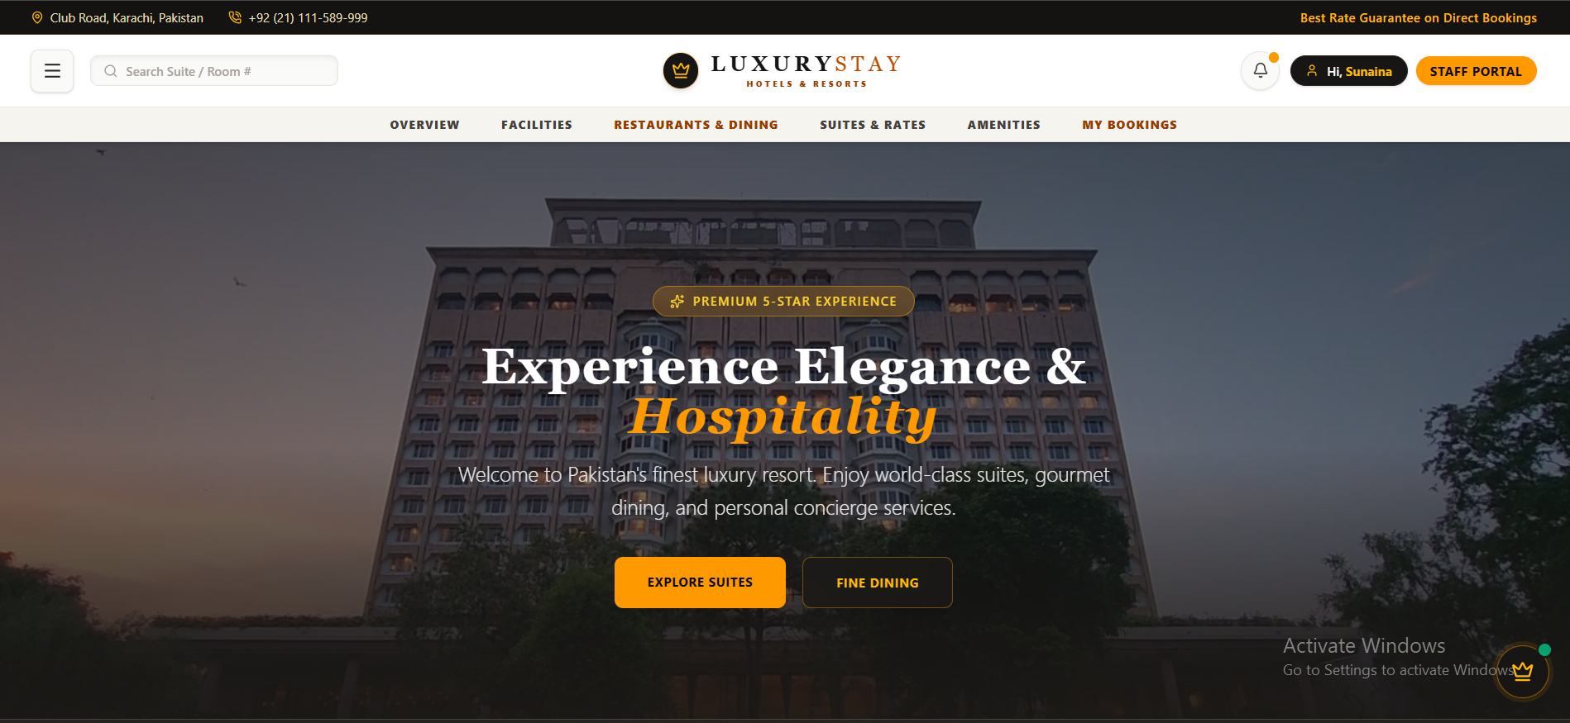
HOME PAGE:

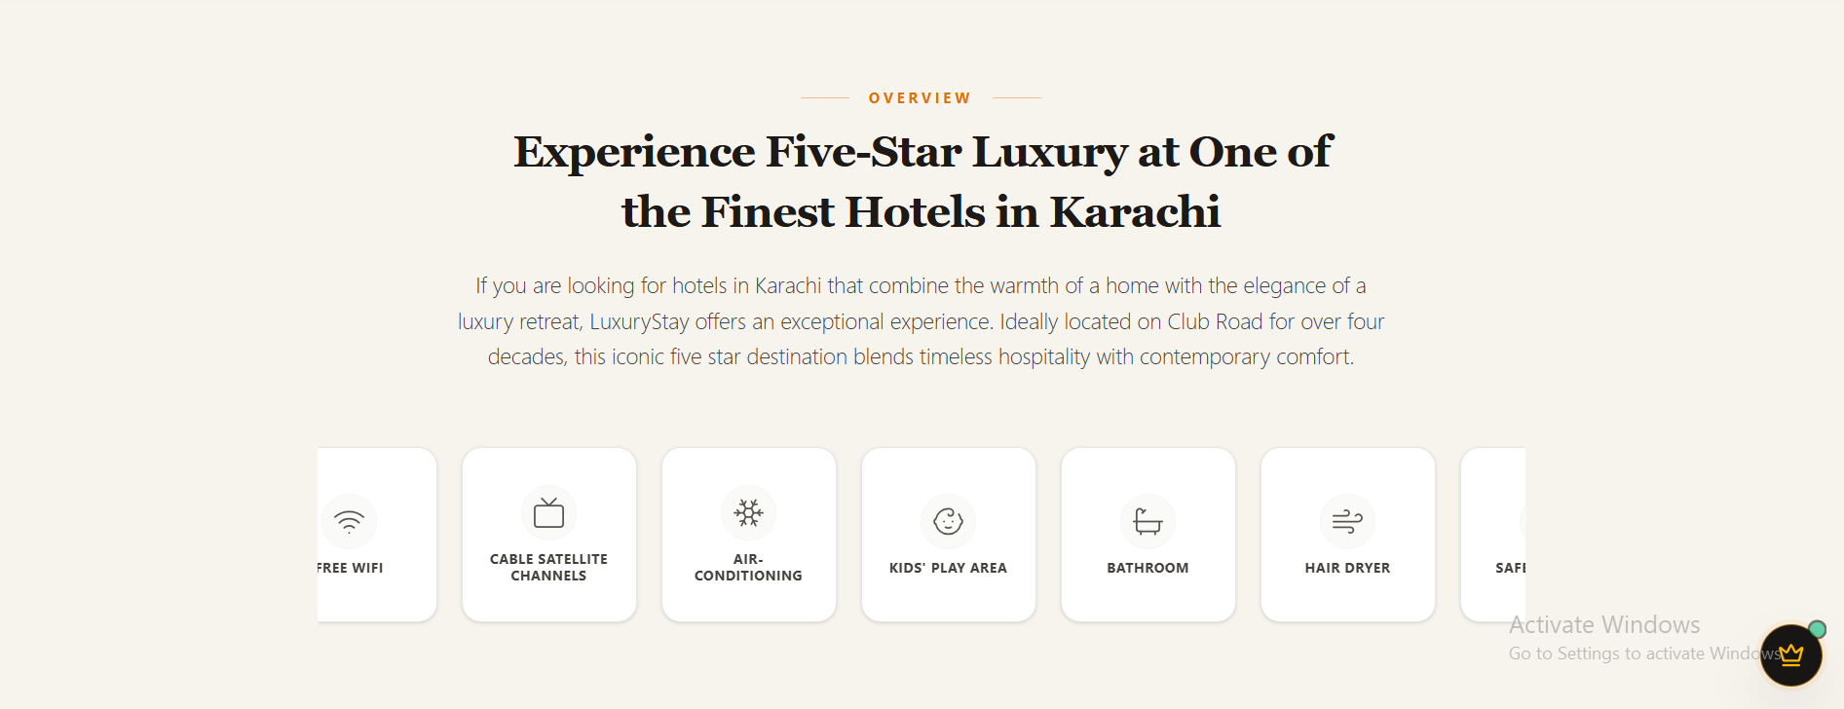

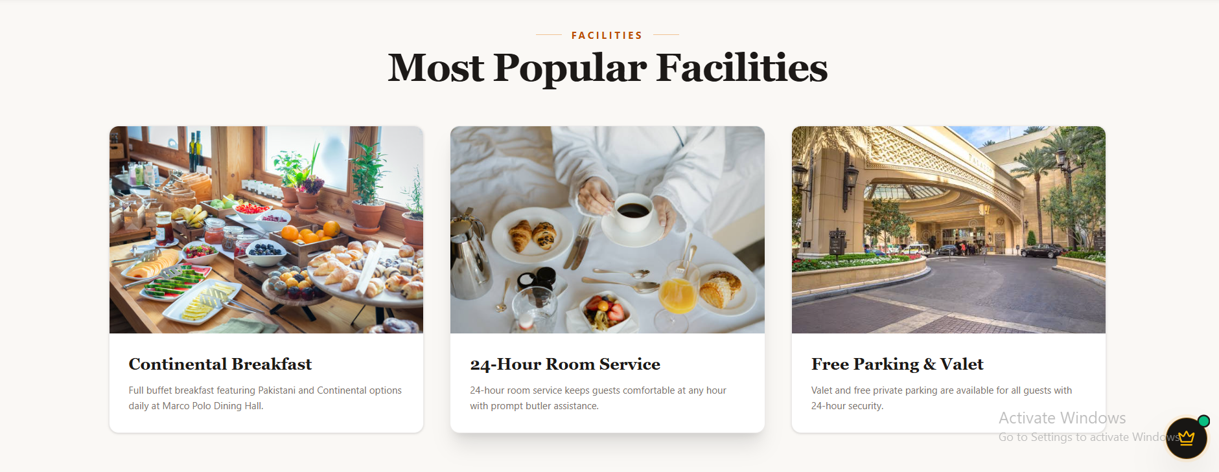

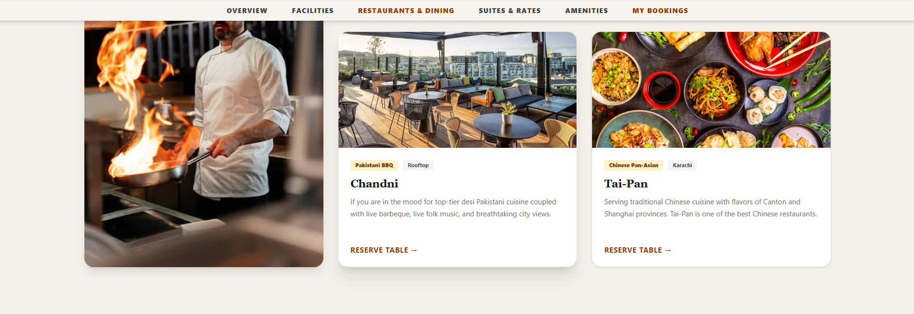
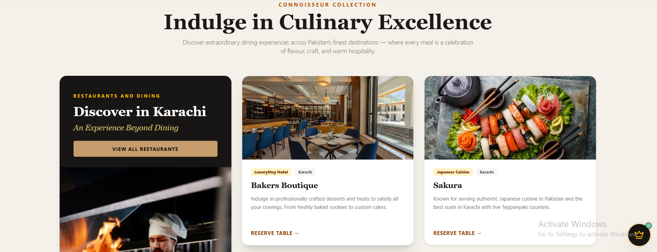

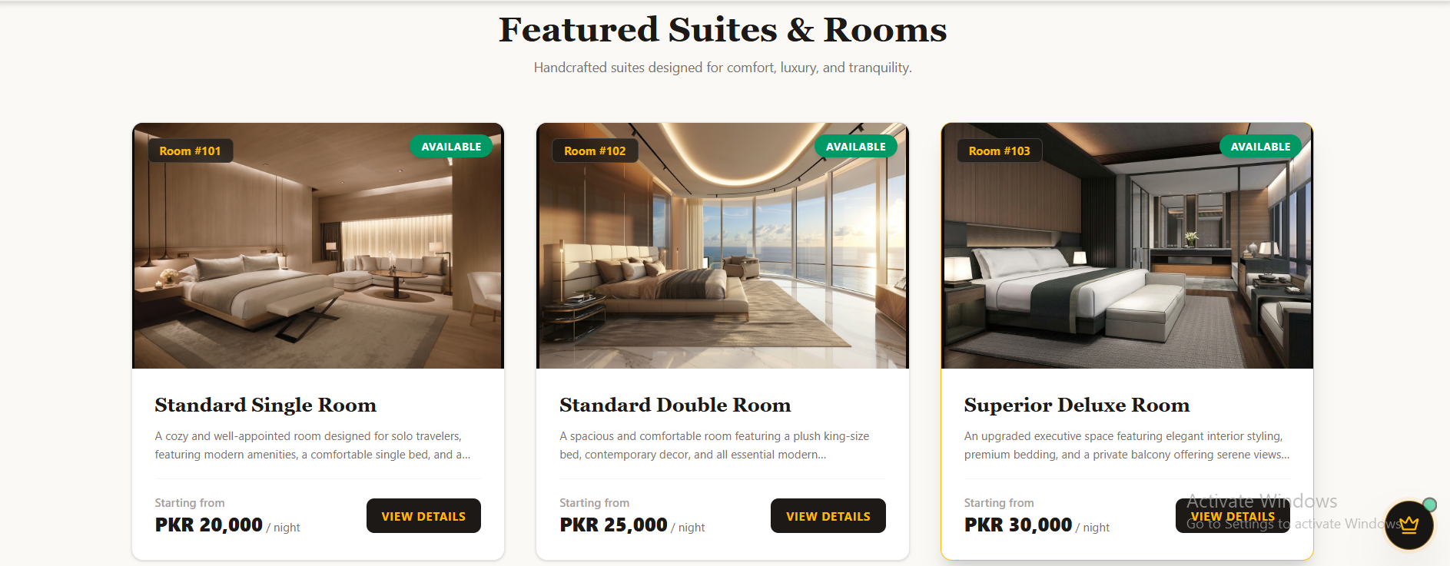

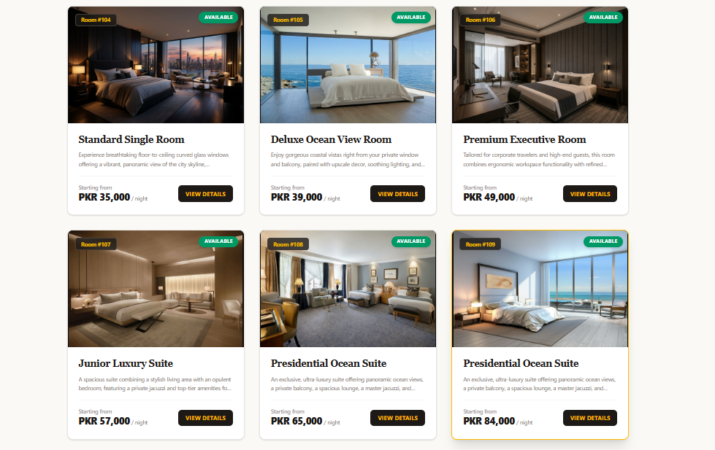
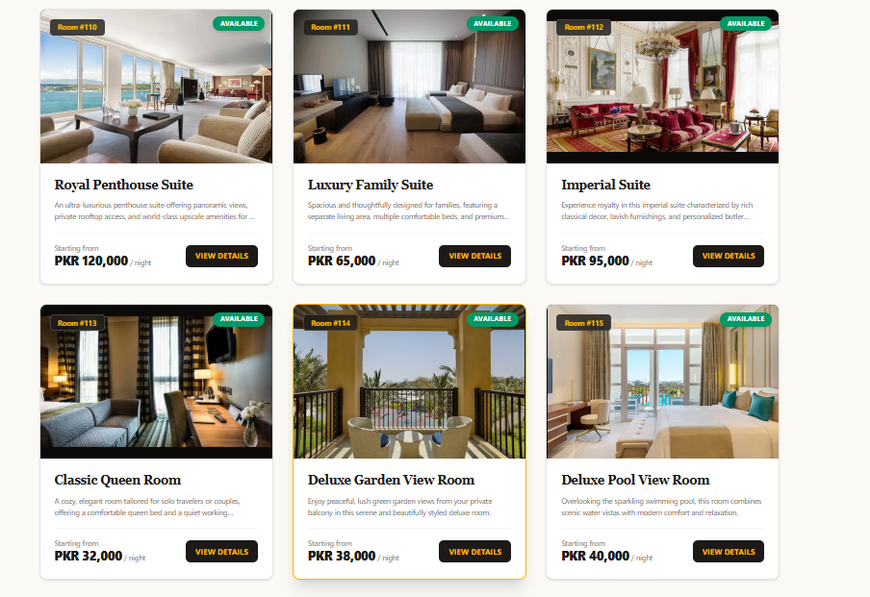

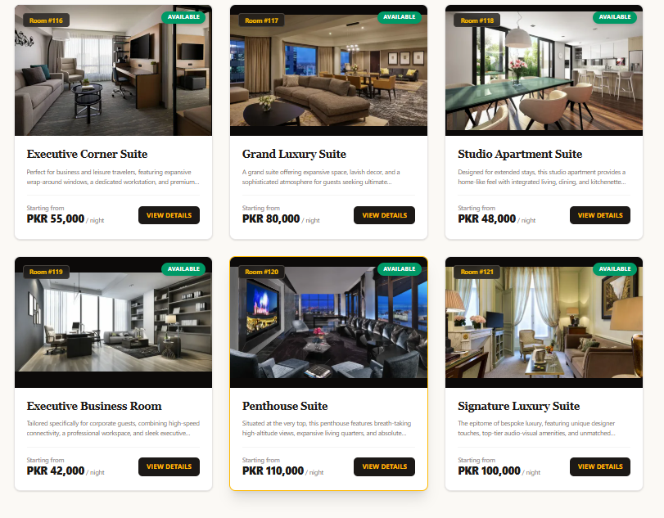

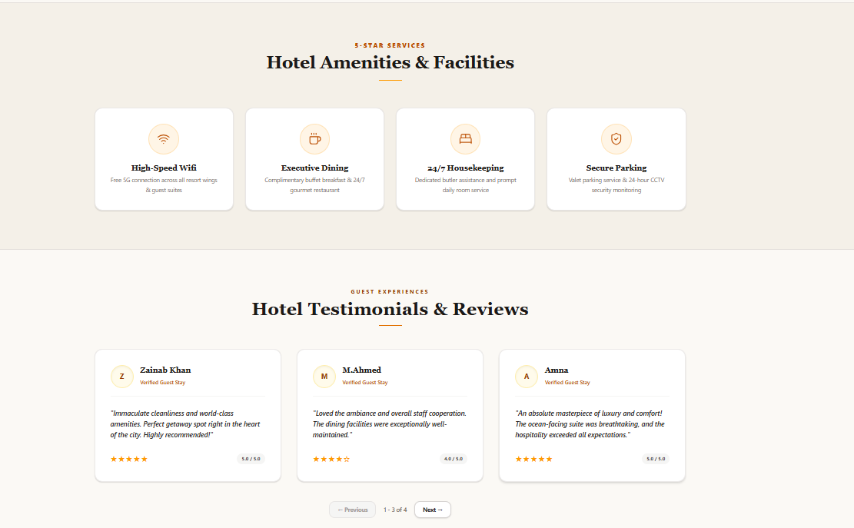

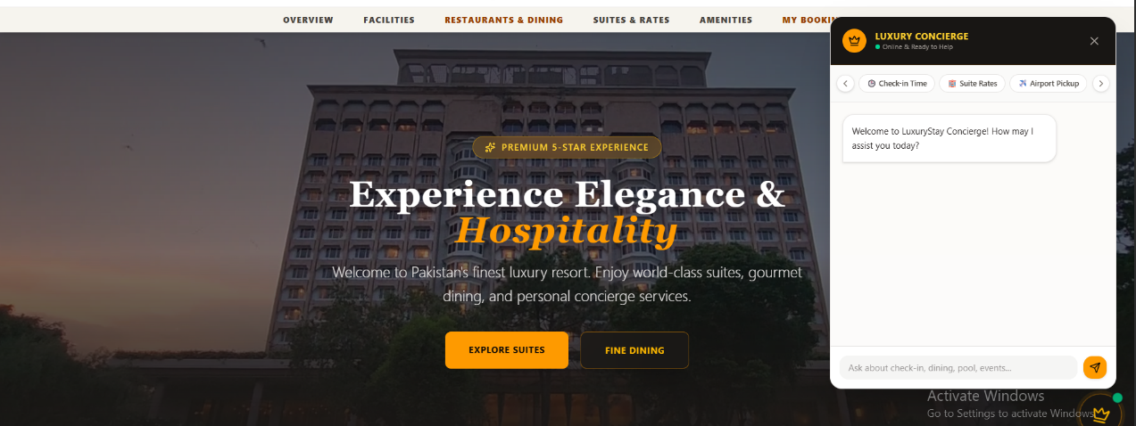

CHATBOT:

FOOTER:
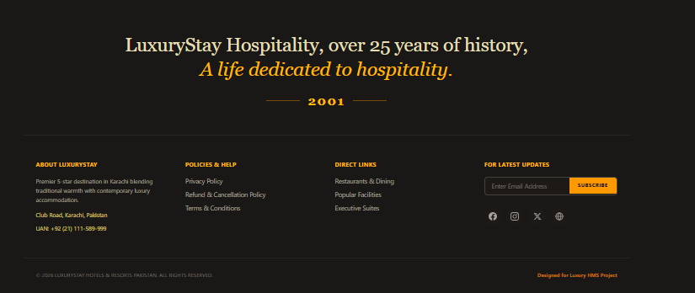

Site Bar

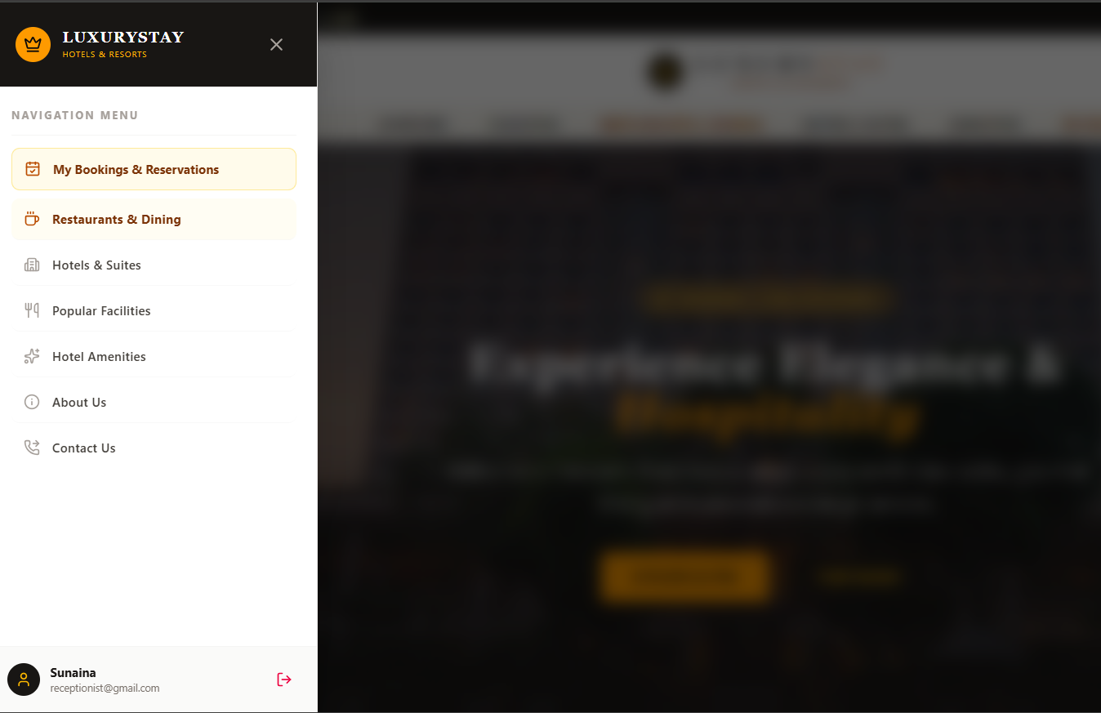

Bookings:
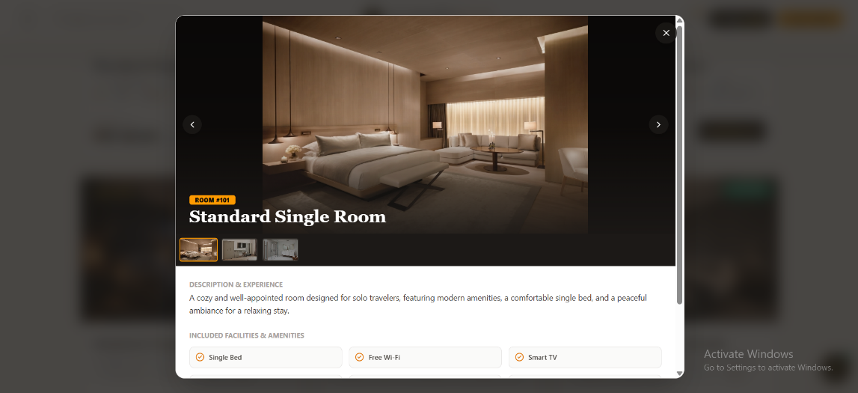

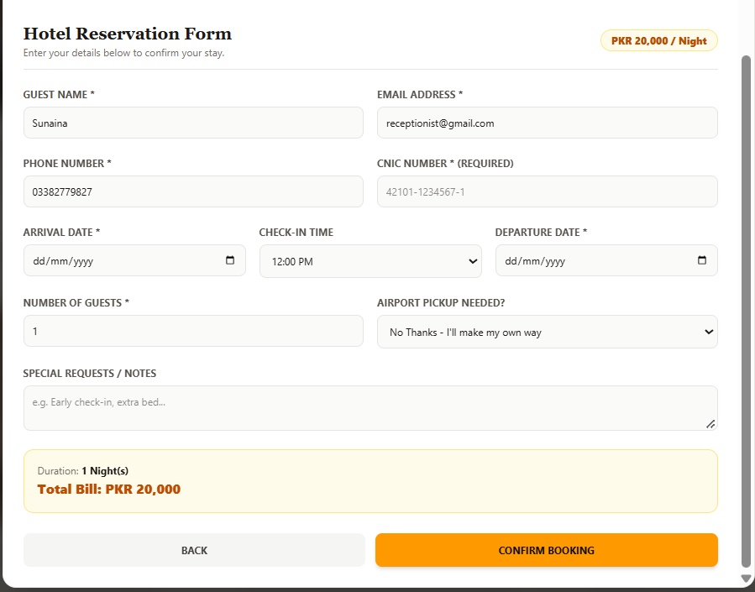
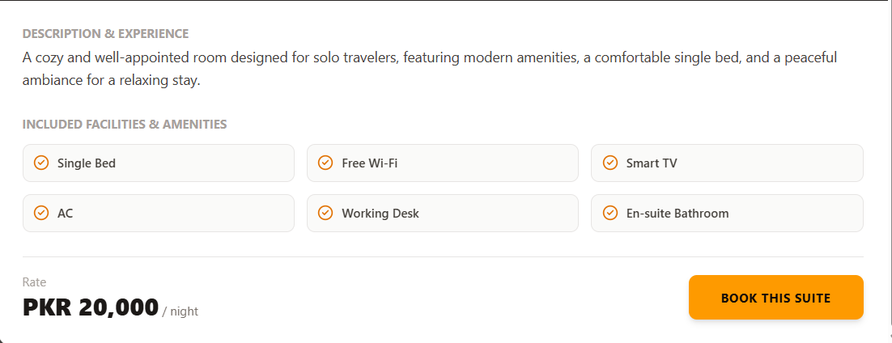
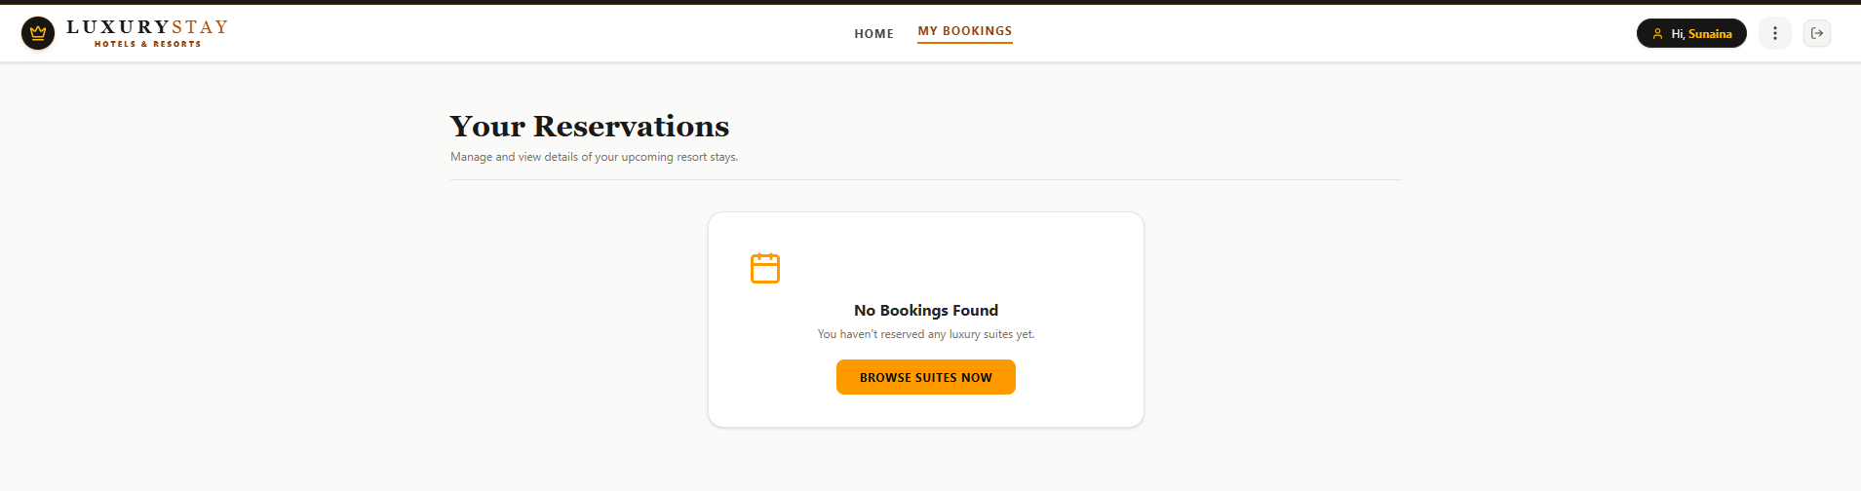

ABOUT PAGE:

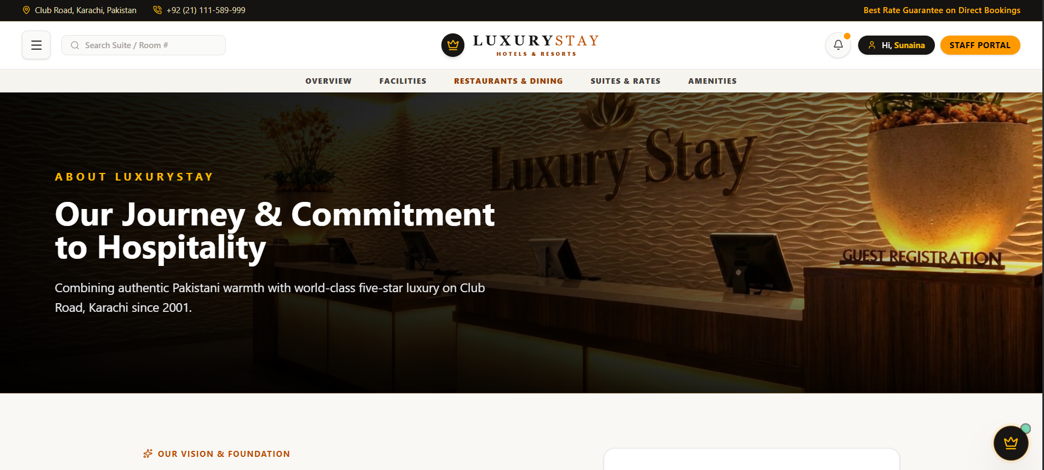

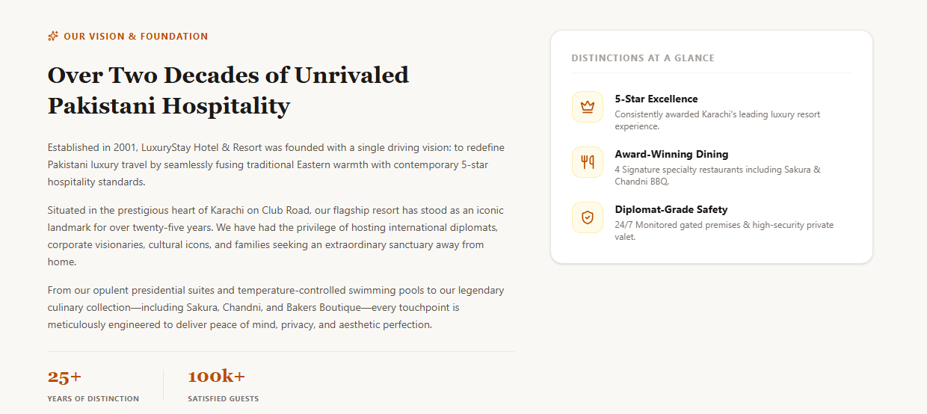

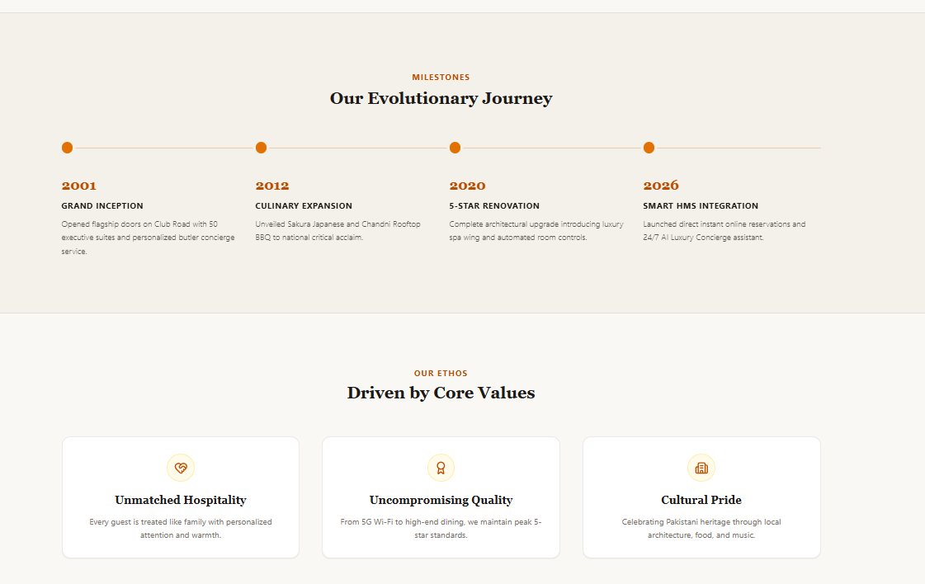

CONTACT PAGE:

